**Technical Specification Document**

**Project Name**: BTL Information Management Web Portal

**Objective**: Centralize and streamline BTL activity tracking, reporting, and analytics across all dealer points and DO’s.

**System Architecture Overview**

**Architecture Type**: Web-based (for excel upload), App-based (for API Sync with Udaan Pro)

**Deployment**: Cloud-hosted (Azure)

**Data Flow**:

* **Data Management** -

Input from Excel,

Udaan Pro API,

Manual entry forms,

Data Validation and Error Handling

* **Centralized database stores all activity data** -

Role-based access (Admin, Zonal, State, Local)

* **Dashboard and analytics layer for visualization** –

Filters: Region, Dealer, Activity Type, Time Period

Visuals: Completion charts, heatmaps, trends

Export: PDF, Excel reports

* **Notification engine for alerts -**

Email/SMS alerts for: Delayed activities,

Missing uploads,

Regional anomalies

* **Integration**:

Udaan Pro: API integration for contractor/mason meeting data

Excel Uploads: File parser to ingest structured Excel data

Manual Entry: Form-based UI for Give Away & POP data

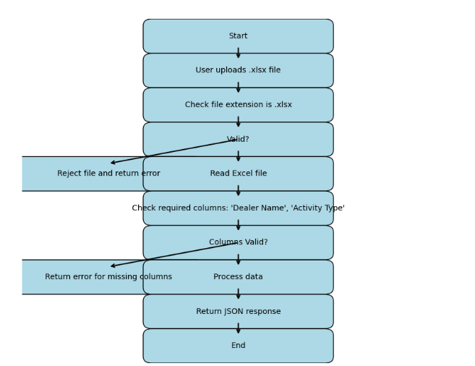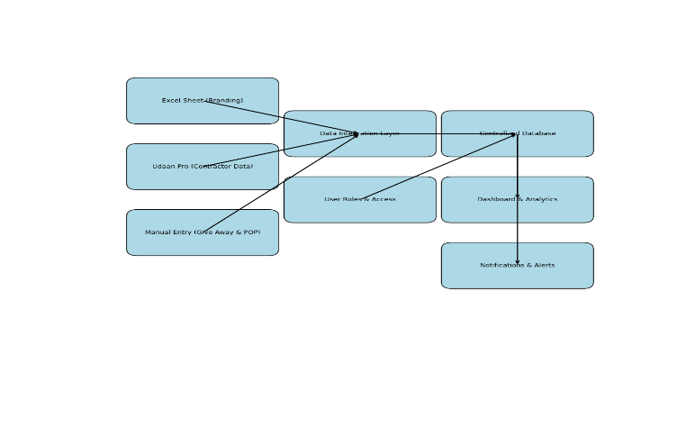

**(Basic Workflow of ExcelUploadWebPortal) (API Sync with Udaan Pro)**

**Core Functionalities in ExcelUploadWebPortal**

**Tech Stack Summary**

* **Frontend**: HTML, CSS, JavaScript (with XLSX library)
* **Backend**: Node.js with Express, Multer, MySQL, XLSX
* **Database**: Relational (MySQL) with tables for Elements, Attributes, UOMs, and DealerMarketingExecution
* **Authentication**: SSO (Single Sign-On) based app authorization and validation.

**1. Excel File Upload**

* Users can upload .xlsx or .xls files.
* Upload interface supports both drag-and-drop and file browsing.
* File size is restricted to 2MB for performance and security.

**2. Client-Side Excel Preview & Validation**

Before uploading, users see a live preview of the Excel file. The system checks for:

* Valid Element names.
* Valid Attribute values for each Element.
* Correct UOM (Unit of Measure) for each Element.
* Errors are highlighted directly in the preview table.

**3. Server-Side Validation & Database Insertion. After submission, the backend:**

* Validates required columns.
* Checks if Element, Attribute, and UOM exist in the database.
* Inserts valid rows into the DealerMarketingExecution table.
* Returns detailed error messages for invalid rows.

**4. Downloadable Sample Template**

* Users can download a pre-formatted Excel template to understand the correct structure for uploads.
* This helps reduce upload errors and improves user experience.

**5. Downloadable Error Report**

If validation fails, users receive:

* A downloadable Excel file containing the original data and a column with detailed error messages.
* This helps user’s correct issues and re-upload successfully.

**6. User Feedback & Interactivity**

* Success and error messages are shown clearly.
* A spinner indicates upload progress.
* Error messages are styled and easy to read.
* Download links for error reports are dynamically generated.